AGENTS AND DISTRIBUTORS SUPPORT

Previously, we analyzed influence from [commission](http://gmcworld.org/blog/agents-and-distributors-commission) and [number of agents and distributors](http://gmcworld.org/blog/agents-and-distributors-number) on demand. In this topic, we analyze dependence of demand on agents and distributors support.

Regarding EU and Nafta markets, support is not affected on demand at all. Influence on demand has only change in support of Internet agent. Clean tests to find formula describing this dependence is few, only 4 reports.

**Test - Scenario 12С1 - Product 1 (Internet)**

Chart shows results of support change of the Internet agent. Vertical - relative change in demand compared to 5 history report for 1 product in Internet market. Horizontal - absolute value of support. Relationship between demand and reward is power function, decreasing.

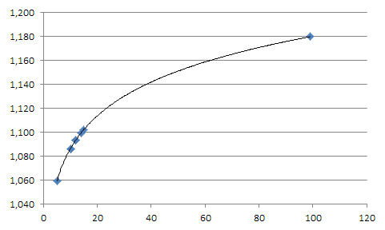

**Hints**

1．Dependence is power function

2．Effect has influence on Internet market only

3．Effect is equal for all products

代理商和经销商的支持费用

以前，我们分析了佣金和代理商和分销商的需求情况。 在这个主题中，我们分析需求对代理商和分销商支持的依赖。

关于国内和北美市场，支持不受需求的影响。对需求的影响只能在互联网代理商的支持下发生变化。完美测试找到描述这种依赖的公式很少，只有4个报告。

**测试 - 情景12C1 - 产品1（互联网）**

Chart shows results of support change of the Internet agent. Vertical - relative change in demand compared to 5 history report for 1 product in Internet market. Horizontal - absolute value of support. Relationship between demand and reward is power function, decreasing.

图表显示了互联网代理商支持变更的结果。 纵向－相对于历史报告互联网市场产品1的相对变化。水平－支持的绝对值。需求与支持费用之间的关系是冥指数函数，递减。



**Hints**

1．依赖于幂指数函数

2．仅对互联网市场有影响

3．对所有产品的影响效果相同